UK Toy Dog
Judge Mr Geoffrey Davies
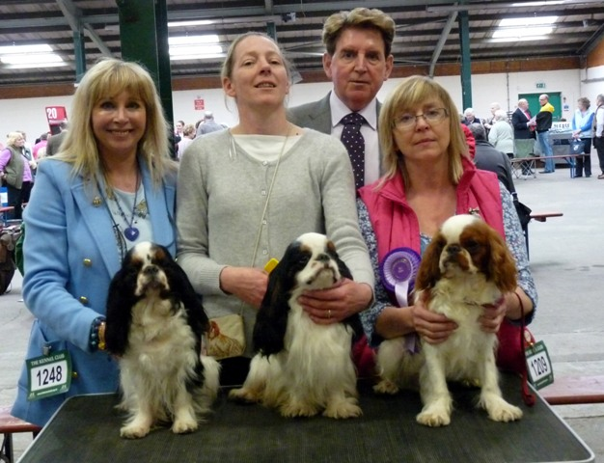
Caroline Robinson with Bitch CC CH Nastane Miss Dior Avec Baldgagon, Tanya Ireland with Dog CC & BOB CH Maibee Theo
Judge Geoffrey Davies and Tracy Jackson with Best Puppy Amantra Summer Chapter

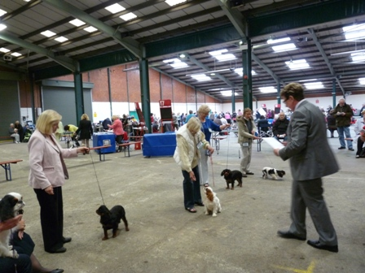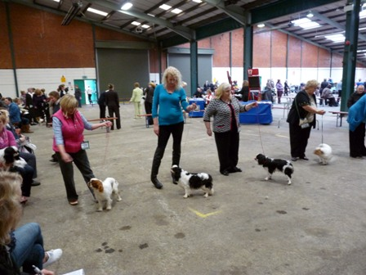
Minor Puppy Dog Winners Puppy Dog winners
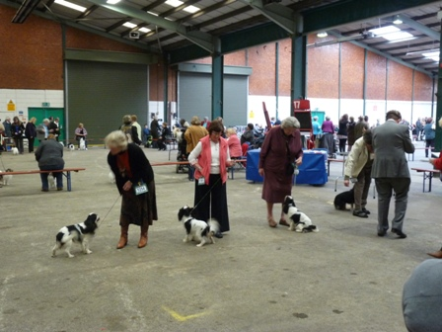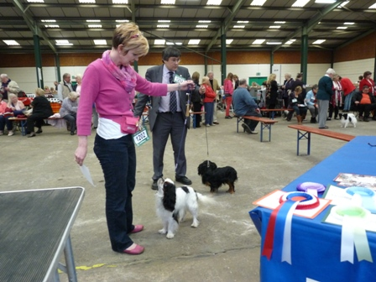
Junior Dog Winners Graduate Dog Winners
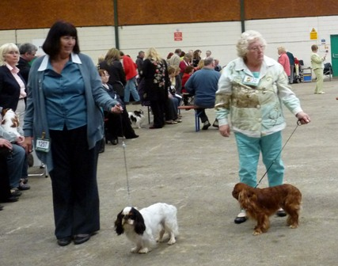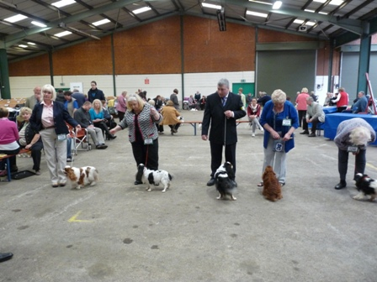
Post Graduate Dog Winners Limit Dog Winners
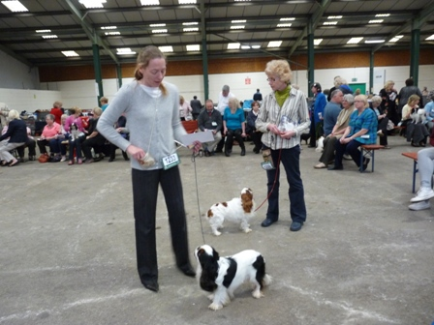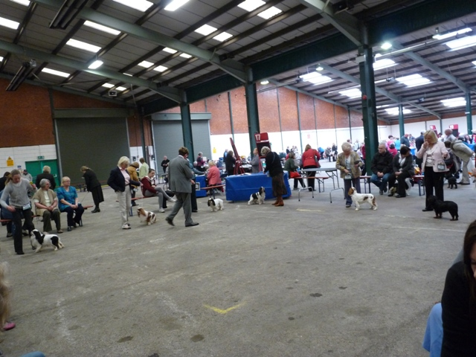
Open Dog Winners Dog CC Line up

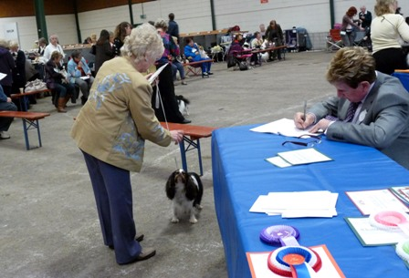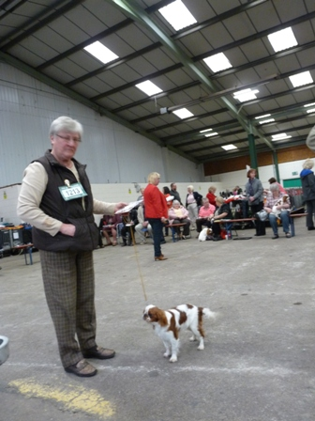
Veteran Bitch Minor Puppy Bitch Winner
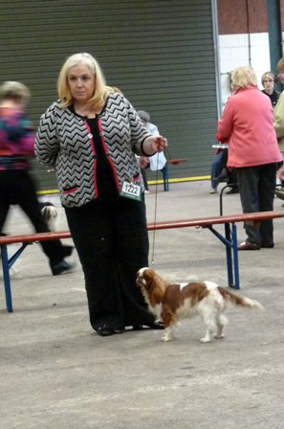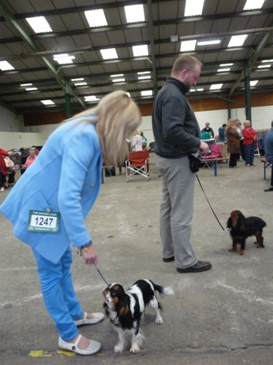
Puppy Bitch Winner Junior Bitch Winner
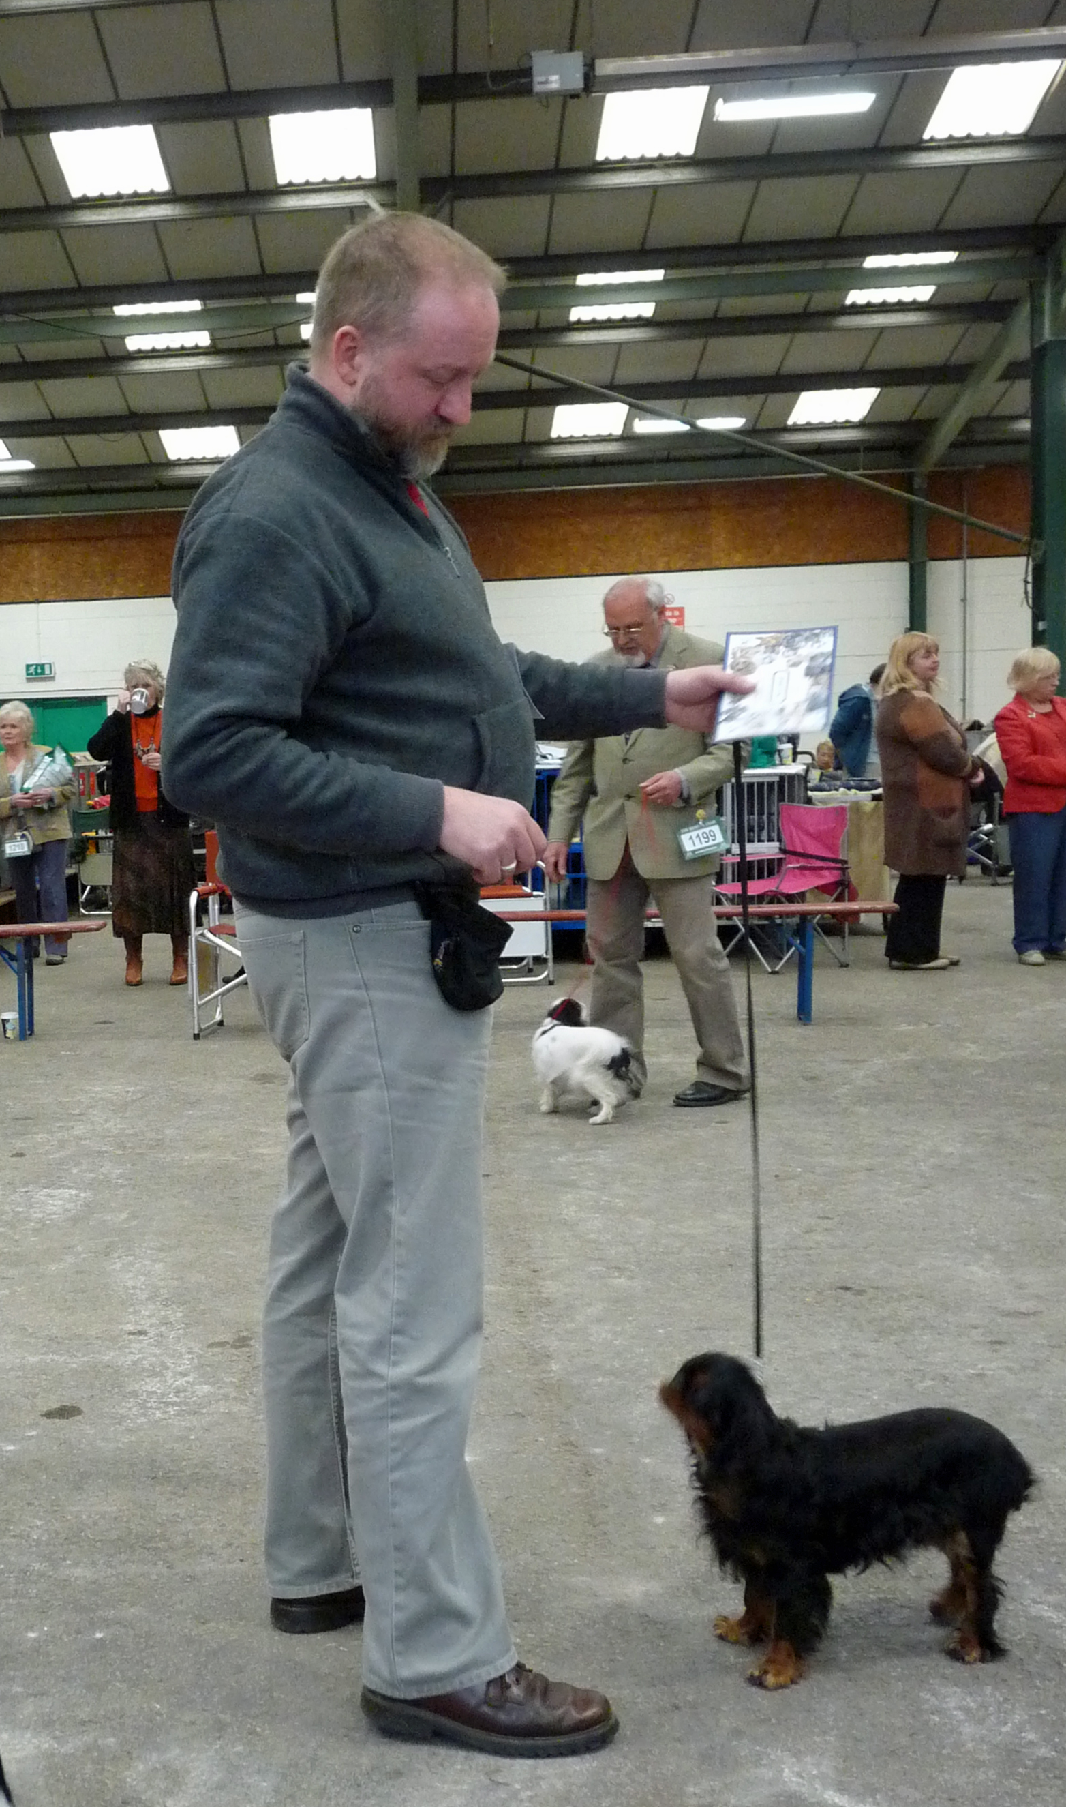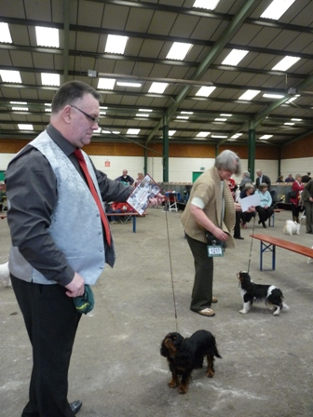
Graduate Bitch Winner Post Graduate Bitch Winners
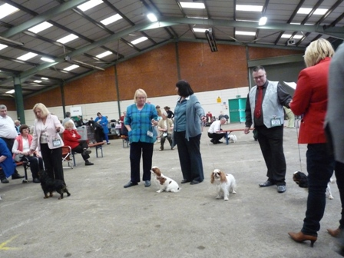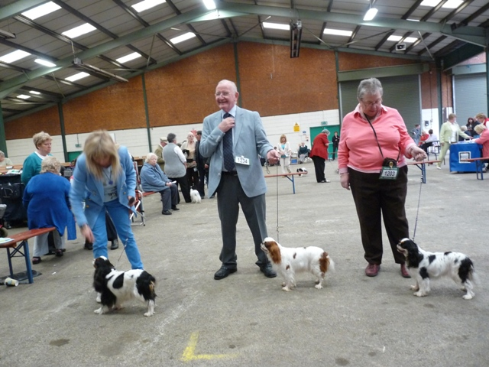
Limit Bitch Winners Open Bitch Winners
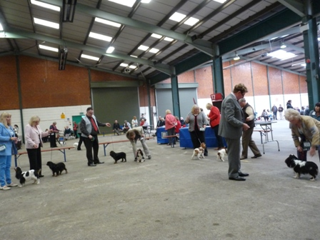
Bitch CC Line Up

